Consider the following C program. Assume there are no syntax errors and the program executes correctly. Assume the fork system calls succeed. What is the output printed to the screen when we execute the below program?
void main(argc, argv) { for(int i = 0; i < 4; i++) { int ret = fork(); if(ret == 0) printf("child %d\n", i); } }
Ans: The statement “child i” is printed 2 i times for i=0 to 3
What takes place during a system call?
To support trap handling, the OS has to set up a trap table of some kind; the trap table is used by the hardware to know which OS code to run when a particular trap occurs. How does the OS inform the hardware of the location of the trap table?
Timer interrupts are a useful mechanism for the OS. Why?

One of the best scheduling policies out there is shortest-time-to-completion first, or STCF. What does STCF do? If it's so great, why do we rarely see it implemented?

Q4. a) Lottery scheduling uses tickets to represent a share of the CPU. Does lottery scheduling prevent starvation? [1m]

Q. Given a system with a quantum length of 10 ms in its highest queue, how often would you have to boost jobs back to the highest priority level to guarantee that a single long-running (and potentially starving) job (let’s say job A) gets at least 5% of the CPU?

WORST CASE: some combination of n short jobs consumes all remaining time of without relinquishing the CPU
Batch job A starts, runs for full quantum of 10ms ♣ If 10ms is 5% of the CPU, when must the priority boost be ??? ♣ ANSWER ◊ Priority boost should occur every 200m

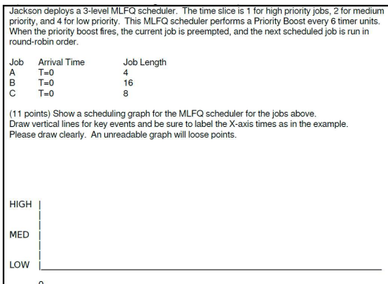

Consider the following code from the provided `fork_shape.c' file

| 1 // fork_shape.c: predict the shape of this set of fork() calls
| 2 #include <stdio.h>
| 3 #include <unistd.h>
| 4 #include <wait.h>
| 5 int main(void) {
| 6 pid_t pid = -1;
| 7 for(int i=0; i<4; i++){
| 8 pid = fork();
| 9 if(pid != 0){
| 10 break;
| 11 }
| 12 }
| 13 waitpid(pid, NULL, 0);
| 14 printf("pid = %d, parent pid = %d\n", getpid(), getppid());
| 15 return 0;
| 16 }

- How many total processes will print their PIDs?
- What shape of process hierarchy will this code produce? Draw a picture of it.
- Will the order of printing be consistent or arbitrary? Why?

Write flow of handling a system call
Why we need two system calls fork and exec ?
what are the components of process or explain Process Control Block?
what are the different states of process and explain the transitions between them (when does a process moves from one state to other)?
A process is a dynamic object, but a program is a static object. State whether given statement is true or not. If true, then elaborate.

Q. Using a basic system call as an example (e.g., getpid or uptime), describe what is normally involved in obtaining the result, from the point when the function in the C library is called to the point where the function returns.
The userspace program makes a function call to the C library, e.g. 'uptime', which sets up a system call in the appropriate manner for the hardware. The userspace program must set up parameters appropriately then trap, such that the kernel takes control and processes the request in userspace. In MIPS, this is achieved through the syscall instruction.
Once the kernel has control, the user state is saved. The kernel performs necessary security & sanity checks, then attempts to fulfill the request. In the case of 'uptime', it would copy the value of a counter, which (presumably) has been counting seconds since powerup. The user state is restored, the counter is placed this in the stack or a register and warps back to userspace. The C library routine reads the stack / register that the kernel just wrote, and returns it to the userspace program.

Why must the operating system be more careful when accessing input to a system call (or producing the result) when the data is in memory instead of registers?
The operating system needs to verify that the memory being written to / read from is a valid address, owned by the process making the request. It must prevent processes from corrupting other processes, or reading memory owned by other processes.

The operating system much take care with inputs from memory as:
a) The address given by the application as the address of the input or output could be
- an address of an illegal area of memory
- an address of a legal area that is paged to disk
b) or, could change if the application is multithreaded.
Basically, the operating system must ensure that it cannot be corrupted, crashed, or bypassed as a result of accessing memory as directed by the application.

Describe a sequence the sequence of step that occur when a timer interrupt occurs that eventually results in a context switch to another application.
- Thread 1 running happily
- Timer tick
- Trap into kernel space
- switch to kernel stack for thread 1
- thread 1 user registers stored
- find next thread to run (named thread 2) from scheduler
- context switch to thread 2 (change to its kernel stack, make its thread control current, flush tlb)
- thread 2 user registers loaded
- warp into thread 2
- thread 2 running

Context switching between two threads of execution within the operating system is usually performed by a small assembly language function. In general terms, what does this small function do internally?
For a real example of such a function look at the OS/161 mips_switch code

In general, assembly language context swith code does:

Saves enough registers on the stack to eventually return back to the calling C function
stores the stack pointer in the current thread's control block
load the stack pointer from the destinations thread's control block
restores the destination threads registers from its stack
returns to 'C' in the destination thread.

Q7. In a real time system, processes indicate hard constraints about when they need to run. If you were designing a scheduler for such a system, speculate about how would you use that information and what scheduling algorithm you would implement?
. explain the difference between Preemptive Scheduling and Non-Preemptive Scheduling. Give examples of scheduling policies for each of them.
Ans-> In Preemptive Scheduling, the resources are allocated to the process for a limited amount of time and then taken away, and the process is again placed back in the ready queue if that process still has CPU burst time remaining. That process stays in the ready queue till it gets its next chance to executed.

Algorithms based on preemptive scheduling are: Round Robin (RR), Shortest Remaining Time First (SRTF), Priority (preemptive version), etc.
Non-Preemptive Scheduling: In this scheduling, once the resources (CPU cycles) are allocated to a process, the process holds the CPU till it gets terminated or reaches a waiting state.
Algorithms based on non-preemptive scheduling are: Shortest Job First (SJF basically non preemptive) and Priority (non-preemptive version), etc.

Q13.Consider the following code fragment:
if (fork() == 0)
{ a = a + 5; printf(“%d,%d\n”, a, &a); }
else { a = a –5; printf(“%d, %d\n”, a, &a); }
Let u, v be the values printed by the parent process, and x, y be the values printed by the child process. Which one of the following is TRUE?
  - u = x + 10 and v = y
  - u = x + 10 and v != y
  - u + 10 = x and v = y
  - u + 10 = x and v != y Answer (c)
fork() returns 0 in child process and process ID of child process in parent process.
In Child (x), a = a + 5
In Parent (u), a = a – 5; Therefore x = u + 10.
The physical addresses of ‘a’ in parent and child must be different. But our program accesses virtual addresses (assuming we are running on an OS that uses virtual memory). The child process gets an exact copy of parent process and virtual address of ‘a’ doesn’t change in child process. Therefore, we get same addresses in both parent and child.

Q14: Consider three processes, all arriving at time zero, with total execution time of 10, 20 and 30 units, respectively. Each process spends the first 20% of execution time doing I/O, the next 70% of time doing computation, and the last 10% of time doing I/O again. The operating system uses a shortest remaining compute time first scheduling algorithm and schedules a new process either when the running process gets blocked on I/O or when the running process finishes its compute burst. Assume that all I/O operations can be overlapped as much as possible. For what percentage of time does the CPU remain idle?
According to question, we have-

 | Total Burst Time | I/O Burst | CPU Burst | I/O Burst
Process P1 | 10 | 2 | 7 | 1
Process P2 | 20 | 4 | 14 | 2
Process P3 | 30 | 6 | 21 | 3

The scheduling algorithm used is Shortest Remaining Time First.

Gantt Chart-

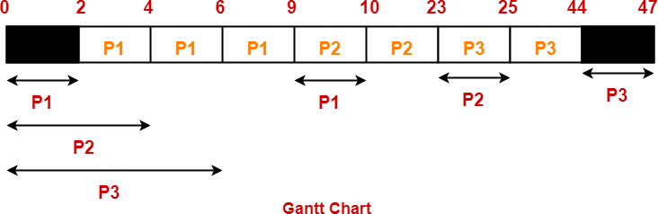
Percentage of time CPU remains idle
= (5 / 47) x 100
= 10.638%

Q17. Consider the collection of these five processes, whose arrival and burst times are provided :-

P Id | Arrival time | Burst time
P1 | 3 | 1
P2 | 1 | 4
P3 | 4 | 2
P4 | 0 | 6
P5 | 2 | 3

Calculate the average waiting time and average turnaround time if the CPU scheduling policy is SJF preemptive.

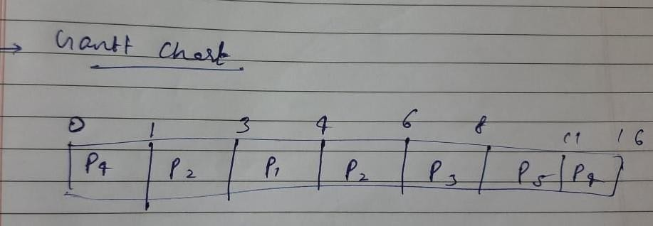
Ans.-
Turn Around time = Exit time – Arrival time
Waiting time = Turn Around time – Burst time

Process Id | Exit time | Turn Around time | Waiting time
P1 | 4 | 4 – 3 = 1 | 1 – 1 = 0
P2 | 6 | 6 – 1 = 5 | 5 – 4 = 1
P3 | 8 | 8 – 4 = 4 | 4 – 2 = 2
P4 | 16 | 16 – 0 = 16 | 16 – 6 = 10
P5 | 11 | 11 – 2 = 9 | 9 – 3 = 6
Average Turn Around time = (1 + 5 + 4 + 16 + 9) / 5 = 35 / 5 = 7 unit
Average waiting time = (0 + 1 + 2 + 10 + 6) / 5 = 19 / 5 = 3.8 unit

Consider the set of 6 processes whose arrival time and burst time are given below

Process Id | Arrival time | Burst time
P1 | 5 | 5
P2 | 4 | 6
P3 | 3 | 7
P4 | 1 | 9
P5 | 2 | 2
P6 | 6 | 3

If the CPU scheduling policy is Round Robin with time quantum = 3, calculate the average waiting time and average turn around time.

Solution :

Ready Queue :
P3, P1, P4, P2, P3, P6, P1, P4, P2, P3, P5, P4

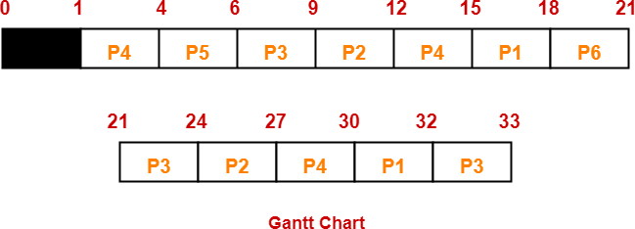

Now, we know-
- Turn Around time = Exit time – Arrival time
- Waiting time = Turn Around time – Burst time

Process Id | Exit time | Turn Around time | Waiting time
P1 | 32 | 32 – 5 = 27 | 27 – 5 = 22
P2 | 27 | 27 – 4 = 23 | 23 – 6 = 17
P3 | 33 | 33 – 3 = 30 | 30 – 7 = 23
P4 | 30 | 30 – 1 = 29 | 29 – 9 = 20
P5 | 6 | 6 – 2 = 4 | 4 – 2 = 2
P6 | 21 | 21 – 6 = 15 | 15 – 3 = 12

Now,
- Average Turn Around time = (27 + 23 + 30 + 29 + 4 + 15) / 6 = 128 / 6 = 21.33 unit

- In MLFQ scheduling, processes are moved from one scheduler queue to another
based on their behavior. Each such queue has a particular length of time slice for all
processes in that queue. Why might a process be moved from a queue with a short
time slice to a long time slice? How can the operating system tell that it should be
moved?
MLFQ scheduling tries to find a good time slice for each process, where “good” is
defined as a time slice that is suited for the process’ needs. Processes that perform a lot
of I/O need short time slices, since they will probably block on I/O after running for a
short time. They will need to be scheduled fairly often, though, so their I/O is handled
promptly once it is ready. Processes that perform a lot of computation and little I/O
would work best with long time slices, since that will allow them to get much work done
before they are context switched out due to time slice expiration. But if we allow them to
run for such long slices very often, they will hog the processor. So they get scheduled for
longer slices, but less often. A process would move from the short time slice queue to the
long time slice queue if it appeared to require more processing time than it got on the
short time slice queue. That would be detected by the process frequently running to the
end of its short time slice and rarely blocking on I/O requests. The OS can simply count
how often the process finishes executing for each reason and move the process to the
longer time slice queue if it usually uses up its entire short time slices

What is the purpose of a trap table in an operating system? What does it contain?
When is it consulted? When is it loaded?
The trap table is used to specify what actions the operating system should take when a
particular exception occurs. It will contain pointers to exception handling routines,
indexed by a number specifying the particular exception that occurs. It is consulted
whenever an exception actually occurs. It is loaded at boot time and typically will not
change until the next reboot.

1. Describe the two general roles of an operating system, and elaborate why these roles are important.
Operating systems provide:
- a fairly standardised abstraction between hardware and userspace software, that allows userspace software to be written with little concern for the hardware it is running on, and having access to a bunch of useful things like memory, files, screens, i/o etc.
- resource management and allocation to processes & threads. resources include files, memory, cpu runtime, etc.
i) high-level abstractions
why?
- more friendly to programmers
- provides common core for all applications
- hides details of hardware to make application code portable
ii) resource manager
why?
- divides resources amongst competing programs or users according to some system policy to ensure fairness and no starvation where possible.
Q. CFS doesn't doesn't use heuristics to identify interactive tasks—it just makes sure every process gets a fair share of CPU within a set amount of time given the number of runnable processes on the CPU. Briefly state some key ideas of CFS by which this is achieved.

